**PROJECT TITLE: ASSESSMENT OF MARGINAL WORKERS IN TAMILNADU**

**Introduction:**

**have a stable source of income. Tamil Nadu (TN) Marginal Workers typically refers to a specific category of labor force within the state of Tamil Nadu, India. These workers fall within the broader classification of "marginal workers" as defined by the Census of India. Marginal workers are individuals who are engaged in irregular, part-time, or seasonal employment and do not**

**Data Collection :**

**Census data:**

**information about marginal workers is typically collected during national population censuses, providing demographic details such as age, gender, education, and marital status, as well as their economic activity.**

**Employment Surveys :**

**Special employment or labor force surveys are conducted to gather detailed information about the employment status, type of work, and income levels of marginal workers in Tamil Nadu.**

**Occupational and Industrial Data:**

**Data collection includes information about the types of industries or occupations in which marginal workers are employed. This helps understand the distribution of work among different sectors and the nature of employment.**

**Geographic Information:**

**Data about the locations of marginal workers' residences and workplaces is important for analyzing regional disparities and planning interventions.**

**Income and Earnings Data:**

**Collecting data on the income and earnings of marginal workers is essential for assessing their economic well-being and identifying income disparities.**

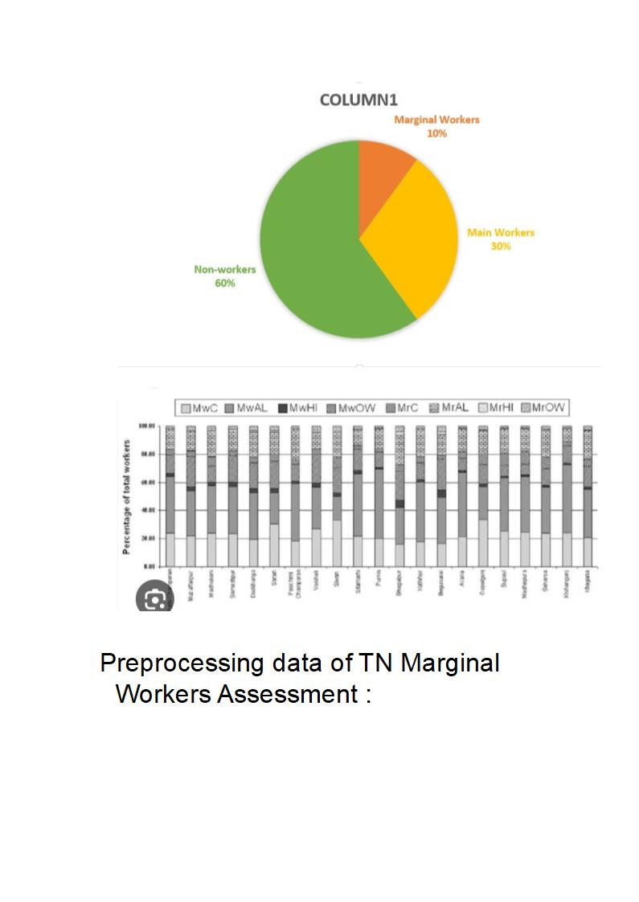

**Preprocessing data of TN Marginal Workers Assessment :**

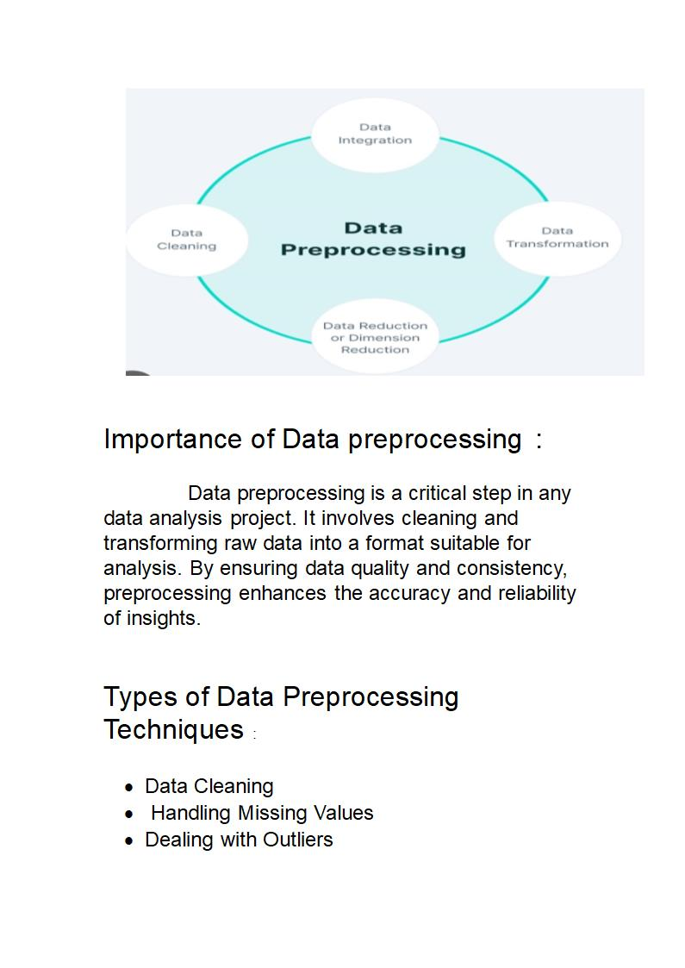

**Importance of Data preprocessing :**

**Data preprocessing is a critical step in any data analysis project. It involves cleaning and transforming raw data into a format suitable for analysis. By ensuring data quality and consistency, preprocessing enhances the accuracy and reliability of insights.**

**Types of Data Preprocessing Techniques :**

**· Data Cleaning**

**· Handling Missing Values**

**· Dealing with Outliers**

**· Feature Scaling**

**· Data Transformation Techniques**

Data Cleaning: A Prerequisite for Accurate Analysis

**Noise Removal :**

**Identifying and eliminating irrelevant or erroneous data points to reduce the impact of outliers and inconsistencies**

**Addressing Inconsistencies :**

**Detecting and resolving inconsistent data entries or formats to ensure uniformity across the dataset.**

**Duplicate Removal :**

**Identifying and eliminating duplicate records to avoid skewing the analysis results and introducing biases.**

**Handling Missing Values: Filling the Gaps :**

**1 Identifying Missing Values Using statistical techniques to identify missing data points and assess their impact on the analysis.**

**2 Imputation Methods Replacing missing values using techniques such as mean, median, mode imputation**

**6 / 12**

**or advanced methods like regression or machine learning.**

**3 Dropping Missing Values Removing rows or columns containing missing values when they cannot be accurately imputed, preserving data.**

**Feature Scaling: Bringing Variables to the Same Scale :**

**Normalization :**

**Scaling each feature to a defined range, often between 0 and 1, to ensure uniformity in the impact of different variables.**

**Standardization :**

**Transforming features to have zero mean and unit variance, ensuring variables with larger magnitudes do not dominate the analysis.**

**Other Techniques :**

**Exploring alternative scaling methods like logarithmic scaling or scaling based on domain knowledge for specific datasets.**

**Data Transformation Techniques: Unleashing Insight :**

**1 Aggregation :**

**Combining or summarizing data values to reduce the dataset's granularity and facilitate higher-level analysis.**

**2 Binning :**

**Grouping continuous data into bins or intervals to transform numerical features into categorical ones for better analysis.**

**3 Encoding :**

**Converting categorical variables into numeric representations to enable their inclusion in mathematical models**

**Challenges of TN Marginal Workers :**

**Understand the Data :**

**Before you start loading and preprocessing the data, it's important to have a good understanding of the dataset's structure, variables, and any potential issues or missing data.**

**Data Gathering :**

**Ensure you have access to the TN Marginal Workers dataset, whether it's provided by an organization, government agency, or available publicly.**

**Data Cleaning:**

**● Deal with Missing Values: Identify and handle missing values in the dataset. You can choose to remove rows with missing values, impute them, or use more sophisticated methods depending on the nature of the data.**

**● Outlier Detection: Identify and handle outliers, which can skew your analysis.**

**● Data Type Conversion: Ensure that data types are consistent and appropriate for analysis.**

**● Handle Duplicates: Check for and remove duplicate records.**

**Data Transformation:**

**● Feature Engineering: Create new features or transform existing ones if it adds value to your analysis.**

**● Scaling and Normalization: Depending on your analysis, you might need to scale or normalize features.**

**● Encoding Categorical Data: If your dataset contains categorical variables, you'll need to encode them into numerical format (e.g., one-hot encoding or label encoding).**

**Data Reduction:**

**● If your dataset is too large, consider dimensionality reduction techniques like Principal Component Analysis (PCA) to reduce the number of features while preserving the most important information.**

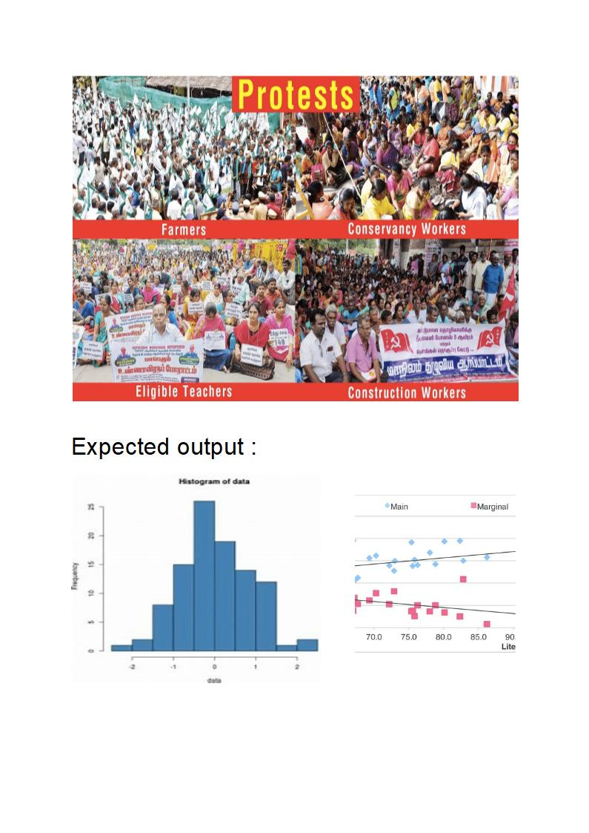

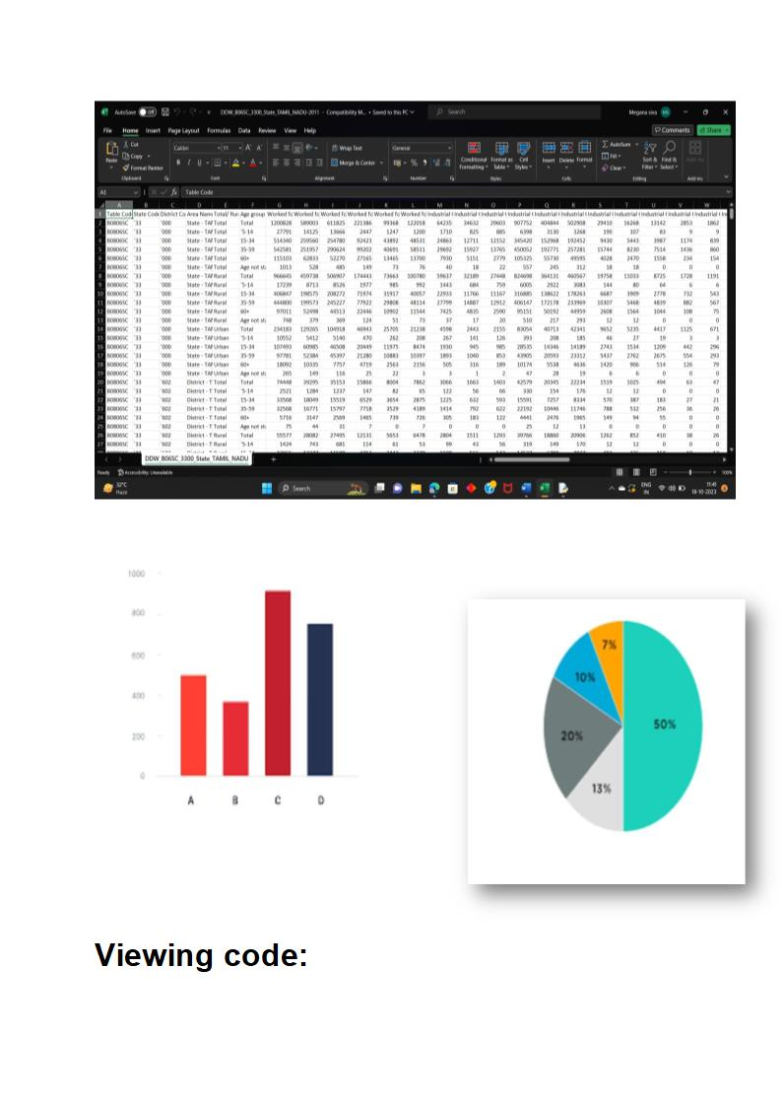

**import pandas as pd**

**import matplotlib.pyplot as plt**

**# Load data from CSV file into a pandas DataFrame**

**data= pd.read_excel('your_excel_file.xlsx',engine='openpyxl')**

**# Assuming your CSV file has columns 'Category' and 'number of Workers'**

**# If your column names are different, modify the next line accordingly**

**categories = data['age group']**

**workers = data['industrial catagory']**

**# Create a bar chart**

**plt.figure(figsize=(10, 6)) # Optional: Set the size of the chart**

**plt.bar(categories, workers, color='skyblue')**

**# Add labels and title**

**plt.xlabel('age group')**

**plt.ylabel('industrial catagory')**

**plt.title('Marginal Workers in Different Categories')**

**# Rotate x-axis labels for better visibility (optional)**

**plt.xticks(rotation=45)**

**# Show the bar chart**

**plt.tight_layout() # Optional: Adjust layout for better appearance**

**plt.show()**

**Conclusion :**

**The conclusion to the topic of marginal workers in Tamil Nadu(TN) would depend on the specific context and research findings. However, in general, it can be concluded that addressing the issues and challenges faced.**